

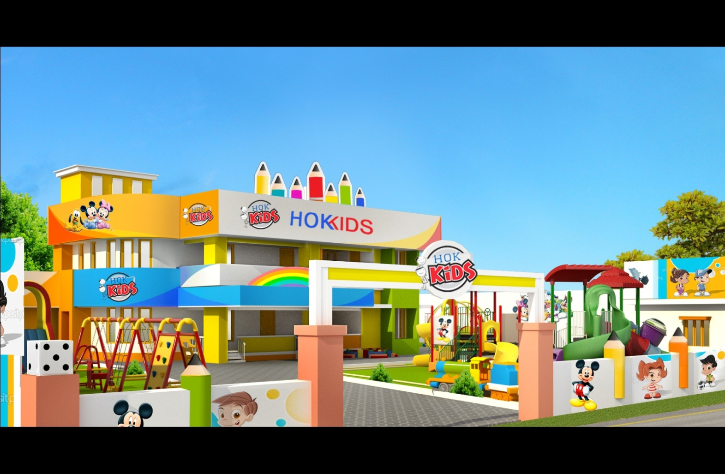

1



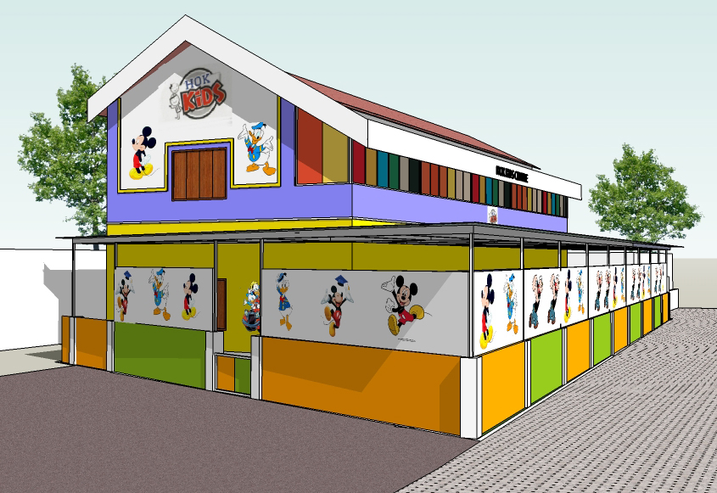



**Hi, My Name Is** :------------------------------------------------

**Paste your photograph**

Paste your photograph aaaaa

My Favourite Food

…………………………………………………….



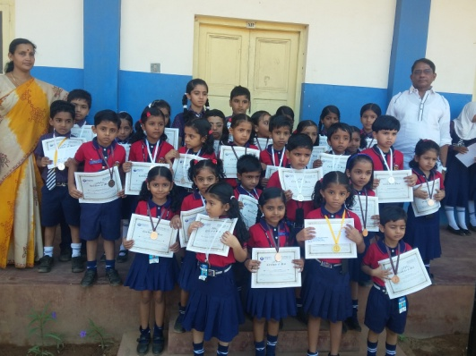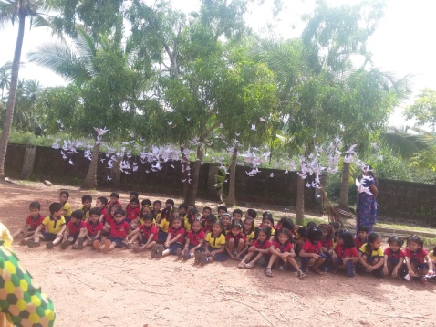 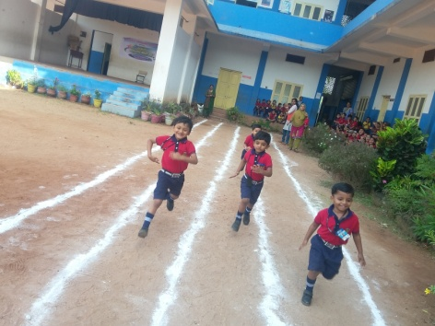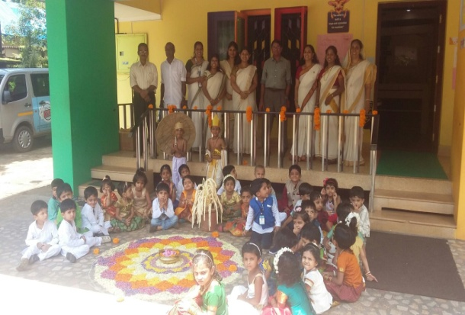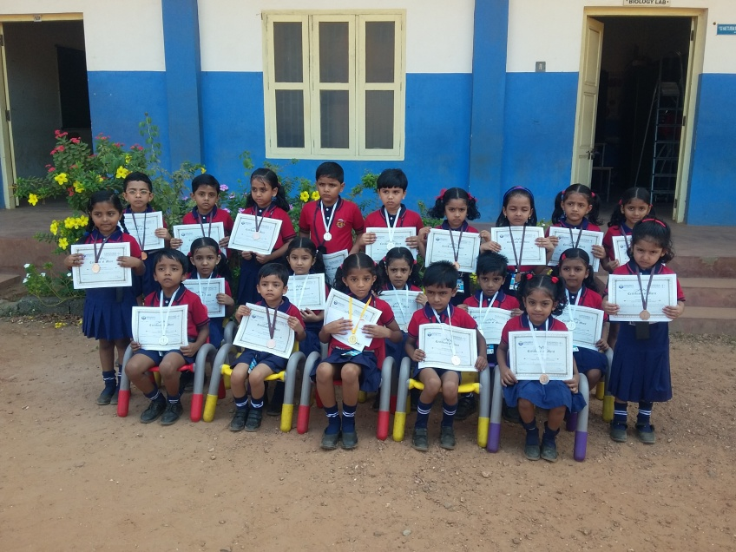

|  | **~ June 2017 ~** | | | | |  | |
| --- | --- | --- | --- | --- | --- | --- | --- |
| **Sun** | **Mon** | **Tue** | **Wed** | **Thu** | **Fri** | | **Sat** |

|  |
| --- |
|  |

|  |  |  |  |  |  |  |
| --- | --- | --- | --- | --- | --- | --- |
|  |  |  |  | 1  https://encrypted-tbn0.gstatic.com/images?q=tbn:ANd9GcQgnJjUP2Tq78OYkvHYYvEgVGlbiQwlAd4kw4brmJLpmyVLTUxF  Reopening  HOK,Edakkad | 2  https://encrypted-tbn1.gstatic.com/images?q=tbn:ANd9GcT0Pz5yHgpAdSrsPKwPTS5n3OZzAhT5ILpHX2ylSZLIXq15MLWCGzwZr80  Transition Day  HOK,Edakkad | 9  C:\Users\LENOVO\Desktop\BE WITH MOM.jpg  Be With  Mom & Dad |
| 4  C:\Users\LENOVO\Desktop\BE WITH MOM.jpg  Be With  Mom & Dad | 5  https://encrypted-tbn0.gstatic.com/images?q=tbn:ANd9GcQgnJjUP2Tq78OYkvHYYvEgVGlbiQwlAd4kw4brmJLpmyVLTUxF  **Opening Day**  **HOK Thalassery** | 6  https://encrypted-tbn1.gstatic.com/images?q=tbn:ANd9GcT0Pz5yHgpAdSrsPKwPTS5n3OZzAhT5ILpHX2ylSZLIXq15MLWCGzwZr80  **Transition Day**  **HOK,Thalassery** | 7  https://encrypted-tbn0.gstatic.com/images?q=tbn:ANd9GcQgnJjUP2Tq78OYkvHYYvEgVGlbiQwlAd4kw4brmJLpmyVLTUxF  **Reopening Day**  **HOK Kannur** | 8  https://encrypted-tbn1.gstatic.com/images?q=tbn:ANd9GcT-LT6-9iBukss1o2J8ecnzu7vK9VopzKv7Na_ewq5rkJGZ87w_  **New Friends Day** | 9  Image result for clip arts toys  time  **Toy’s Day** | 10  C:\Users\LENOVO\Desktop\BE WITH MOM.jpg  Be With  Mom & Dad |
| 11  C:\Users\LENOVO\Desktop\BE WITH MOM.jpg  Be With  Mom & Dad | 12  C:\Users\LENOVO\Desktop\play park.jpg  **Play Park Day** | 13  Image result for clip art nature park  **Nature’s Park Day** | 14  https://encrypted-tbn2.gstatic.com/images?q=tbn:ANd9GcQeUnpu5Nvdo3b2AbZGeFiGTkU1HWTM31vPM0LfAnxhyQNCoUJF  **Puppet’s Day** | 15  https://encrypted-tbn3.gstatic.com/images?q=tbn:ANd9GcSxjww1va8xZ9p434wSfzbdeKzC4VPPs5Evy6I0uRhetyZsxWpC  **Rhyme Day** | 16  C:\Users\LENOVO\Desktop\download.jpg  **Father’s Day** | 17  C:\Users\LENOVO\Desktop\BE WITH MOM.jpg  Be With  Mom & Dad |
| 18  C:\Users\LENOVO\Desktop\BE WITH MOM.jpg  Be With  Mom & Dad | 19  https://encrypted-tbn0.gstatic.com/images?q=tbn:ANd9GcRiUo7Pe5G4P5MS7FFje0Efk3Z_h5WCXauI-tV83x4nbpU3F5qG  **My Name Day** | 20  https://encrypted-tbn3.gstatic.com/images?q=tbn:ANd9GcRfEeHpanNYbFxp0MxeAzmT9UrYwGyLLbNMKeHzV9viazbUr72T  **My Parent’s Name Day** | 21  https://encrypted-tbn2.gstatic.com/images?q=tbn:ANd9GcTOMoPW0J5wZCJWozxPliOv-3FhcTWP6ghkIrjLBSmbW8vGx8Up  **My Grand Parent’s Name Day** | 22  https://tse1.mm.bing.net/th?id=OIP.SHGY_6rvkRZcNu3yVCGywwEsDH&pid=15.1&P=0&w=244&h=164  **Ramadan Celebration** | 23  C:\Users\LENOVO\Desktop\BE WITH MOM.jpg  **Be With**  **Mom & Dad** | 24  C:\Users\LENOVO\Desktop\BE WITH MOM.jpg  Be With  Mom & Dad |
| 25  C:\Users\LENOVO\Desktop\BE WITH MOM.jpg  Be With  Mom & Dad | 26  C:\Users\LENOVO\Desktop\BE WITH MOM.jpg  Be With  Mom & Dad | 27  C:\Users\LENOVO\Desktop\BE WITH MOM.jpg  Be With Mom & Dad | 28  https://encrypted-tbn3.gstatic.com/images?q=tbn:ANd9GcQCyEcheLjs7uoQgCx6gR8cqeupqey1pkMvN_VSTEY6CHPRtxo9  School reopens Story Day | 29  https://encrypted-tbn3.gstatic.com/images?q=tbn:ANd9GcQyMNbyAtcqwVEtBU4D0N3VPG4273NuBaewF0GXr7mNzMcLsBZl  Make a card for doctor | 30  https://s-media-cache-ak0.pinimg.com/236x/05/be/5c/05be5c9d5d8be28772a16f9e8c193cb6.jpg  Field trip – visit to doctor’s clinic |  |

|  | **~ July 2017 ~** | | | | | | |  |
| --- | --- | --- | --- | --- | --- | --- | --- | --- |
| **Sun** | **Mon** | | **Tue** | | **Wed** | **Thu** | **Fri** | **Sat** |
|  |  | |  | |  |  |  | 1  C:\Users\LENOVO\Desktop\BE WITH MOM.jpg http://www.desicomments.com/wp-content/uploads/Happy-Doctor%E2%80%99s-Day.jpg  **Be With**  **Mom & Dad (Doctor’s Day)** |
| 2  C:\Users\LENOVO\Desktop\BE WITH MOM.jpg  **Be With**  **Mom & Dad** | 3  Image result for image of Anti plastic day **Anti Plastic Day** | | 4  **http://4.bp.blogspot.com/_LsKN96BscK4/SqqQ8AALncI/AAAAAAAAMtw/-Hgh_0p3-Bo/s200/rainbow_clipart.gifRainbow Colour’s Day** | | 5  https://tse3.mm.bing.net/th?id=OIP.yrOiULz7JSGoPGZQnIMf9wDoEs&pid=15.1&P=0&w=300&h=300  My Address Day | 6  https://encrypted-tbn2.gstatic.com/images?q=tbn:ANd9GcQEuDfbftL3qpyLNrFMxIejB7je5lvPK0ZnqlxqGqcSe1EtX_a5 **My Contact Number Day** | 7 https://tse3.mm.bing.net/th?id=OIP.Q4hOdkGnzhHLihU3DGLC2gErEs&pid=15.1&P=0&w=300&h=300  Flower’s Day | 8  C:\Users\LENOVO\Desktop\BE WITH MOM.jpg  Be with Mom & Dad |
| 9  C:\Users\LENOVO\Desktop\BE WITH MOM.jpg  **Be With**  **Mom & Dad** | 10  **http://www.scholastic.com/content5/media/products/55/9780395698655_xlg.jpg**  Rain Song Day | | 11  **https://encrypted-tbn1.gstatic.com/images?q=tbn:ANd9GcQeNZj95fYRjkn1RppzIiWwt7tUuanMp5tMXwvedjYVp0IHucjQ**  Rain Dance Day | | 12  http://www.gomanzanillo.com/features/cloud%20forest/animals/smfrog.jpg  Rain Creatures Day | 13  https://encrypted-tbn0.gstatic.com/images?q=tbn:ANd9GcS8IHYLAw-X-HN_wx77QhsQFYWRrsu4hBtIirLcoULYTjaNynzJ  Fruit’s Day | 14  https://encrypted-tbn2.gstatic.com/images?q=tbn:ANd9GcRyoMEagKAcesgguiCsZrLa_qqLir6upT4LUVHHIRWH9wcty4-B  Doll Making Day | 15  C:\Users\LENOVO\Desktop\BE WITH MOM.jpg  **Be With**  **Mom & Dad** |
| 16  C:\Users\LENOVO\Desktop\BE WITH MOM.jpg  **Be With**  **Mom & Dad** | 17  https://tse2.mm.bing.net/th?id=OIP.ejnYhXtsGsMPU8YJRQaE6AEsCd&pid=15.1&P=0&w=303&h=160  **Colour’s day**  **YELLOW** | | 18  https://tse1.mm.bing.net/th?id=OIP.81J9EVOjq5qv5UOJPpSTOgEsC2&pid=15.1&P=0&w=302&h=185  **My Parent’s Day** | | 19  Image result for clip art on my  grand parents day  **My Grand Parent’s Day** | 20  https://encrypted-tbn3.gstatic.com/images?q=tbn:ANd9GcROk5UKfwI4wE-UWdIzmAwt05mOUtO1YJaDYkny1uLS48h-w6OF  My Sibling’s Day | 21  http://www.cliparthut.com/clip-arts/22/clip-art-playing-children-543900-22181.jpg  **My Cousin’s Day** | 22  C:\Users\LENOVO\Desktop\BE WITH MOM.jpg  **Be With**  **Mom & Dad** |
| 23  C:\Users\LENOVO\Desktop\BE WITH MOM.jpg  **Be With**  **Mom & Dad (Karkkidakavavu)** | 24  https://encrypted-tbn0.gstatic.com/images?q=tbn:ANd9GcSBPiURF4fZCI1p7-c0Bd9N0W8XxDK7jV90HHUjdb4zFs1r2ZMe  **Primary Colour’s Day** | | 25  http://blogs.murdoch.edu.au/marcotse/files/2011/03/secondary-colours-300x225.jpg  **Secondary Colour’s Day** | | 26  Pink Growing Light  **Light & Dark Shade’s Day** | 27  Related image  **Death Anniversary of Dr. APJ Abdul Kalam** | 28  http://cdn.xl.thumbs.canstockphoto.com/canstock24476170.jpg  **Art**  **Mela** | 29  *C:\Users\LENOVO\Desktop\BE WITH MOM.jpg*  **Be With**  **Mom & Dad** |
| 30  C:\Users\LENOVO\Desktop\BE WITH MOM.jpg  **Be With**  **Mom & Dad** | 31  http://ts4.mm.bing.net/th?id=JN.%2b3HY742m6iPUlGYZFshnOA&pid=15.1&H=156&W=160  **Colour’s Day** |
|  | | |

|  | **~ August 2017~** | | | | | | | |  |
| --- | --- | --- | --- | --- | --- | --- | --- | --- | --- |
| **Sun** | **Mon** | **Tue** | **Wed** | **Thu** | | | **Fri** | | **Sat** |
|  |  | 1  http://www.theholidayspot.com/friendship/clip_art/images/HAPPY031.gif  Friendship Song Day | 2  http://images.clipartpanda.com/friend-clip-art-clipcookies.gif  Friendship Story Day | 3  Image result for clip art on family friends day  **Family Friend’s Day** | | | | 4  https://tse1.mm.bing.net/th?id=OIP.Q9dLgjPILRc7l-neHtQB0wEsDI&pid=15.1&P=0&w=225&h=151  My Best friend Day | 5  C:\Users\LENOVO\Desktop\BE WITH MOM.jpg  **Be With**  **Mom & Dad** |
| 6  C:\Users\LENOVO\Desktop\BE WITH MOM.jpg  **Be With**  **Mom & Dad** | 7  https://tse1.mm.bing.net/th?id=OIP.zDeZCGuqwlHxFrg1N0ExeQEsDe&pid=15.1&P=0&w=208&h=155  **Salute the Soldier’s Day** | 8  https://tse2.mm.bing.net/th?id=OIP.8amVuMzpA-i4NnejwZfFfQEsC5&pid=15.1&P=0&w=258&h=160  Freedom Fighter’s Day | 9  https://tse1.mm.bing.net/th?id=OIP.UQmo2kdmJpOEiKv7w9uFPQDNEs&pid=15.1&P=0&w=300&h=300  **Patriotic Song Day** | 10  https://tse4.mm.bing.net/th?id=OIP.WAnpgTwNcdTITDHvMafViAD_Es&pid=15.1&P=0&w=300&h=300  **Speech On Mahatma Gandhi** | | | 11  https://tse2.mm.bing.net/th?id=OIP.PM6F_FXvbAedze-WMuHCrQDhEs&pid=15.1&P=0&w=300&h=300  Visit Fort (Field Trip ) | | 12  C:\Users\LENOVO\Desktop\BE WITH MOM.jpg  **Be With**  **Mom & Dad** |
| 13  C:\Users\LENOVO\Desktop\BE WITH MOM.jpg  **Be With**  **Mom & Dad** | 14  http://motoki-y.sakura.ne.jp/illust/flag/flag_of_india.gif  **Make a Flag day** | 15  https://tse4.mm.bing.net/th?id=OIP.IEB6luAMhAf62iF8mPJTmwEsCx&pid=15.1&P=0&w=332&h=198  **Independence Day** | 16  https://img0.etsystatic.com/000/0/5893230/il_340x270.342690904.jpg  **Vegetable Printing Day** | 17  **https://tse1.mm.bing.net/th?id=OIP.HFsXAM7yAJnqzQurLI2nlwEaEs&pid=15.1&P=0&w=300&h=300**  Pre Mid Term Exam | | | 18  https://tse1.mm.bing.net/th?id=OIP.HFsXAM7yAJnqzQurLI2nlwEaEs&pid=15.1&P=0&w=300&h=300  Pre Mid Term Exam | | 19  C:\Users\LENOVO\Desktop\BE WITH MOM.jpg  **Be With**  **Mom & Dad** |
| 20  C:\Users\LENOVO\Desktop\BE WITH MOM.jpg  **Be With**  **Mom & Dad** | 21  https://tse1.mm.bing.net/th?id=OIP.HFsXAM7yAJnqzQurLI2nlwEaEs&pid=15.1&P=0&w=300&h=300  Pre Mid Term Exam | 22  https://tse1.mm.bing.net/th?id=OIP.HFsXAM7yAJnqzQurLI2nlwEaEs&pid=15.1&P=0&w=300&h=300  Pre Mid Term Exam | 23  https://tse1.mm.bing.net/th?id=OIP.HFsXAM7yAJnqzQurLI2nlwEaEs&pid=15.1&P=0&w=300&h=300  Pre Mid Term Exam | 24  https://tse1.mm.bing.net/th?id=OIP.HFsXAM7yAJnqzQurLI2nlwEaEs&pid=15.1&P=0&w=300&h=300  Pre Mid Term Exam | | | 25  https://tse1.mm.bing.net/th?id=OIP.HFsXAM7yAJnqzQurLI2nlwEaEs&pid=15.1&P=0&w=300&h=300  Pre Mid Term Exam | | 26  C:\Users\LENOVO\Desktop\BE WITH MOM.jpg  **Be With**  **Mom & Dad** |
| 27  C:\Users\LENOVO\Desktop\BE WITH MOM.jpg  **Be With**  **Mom & Dad** | 28  **https://tse2.mm.bing.net/th?id=OIP.brfkDPIVFuqMxwoUcc1d7AEsDh&pid=15.1&P=0&w=207&h=156**  **Ayyankali Jayanthi Onam Song Day** | 29  **https://tse1.mm.bing.net/th?id=OIP.HsPkkA0gKhH--bQk_XKUgQD4Es&pid=15.1&P=0&w=300&h=300**  **Onam Story day** | 30  https://tse2.mm.bing.net/th?id=OIP.jjmjBrUX4ndi6ncyQ3VjCAEsDI&pid=15.1&P=0&w=241&h=161  **Bakrid Story Day** | 31  https://encrypted-tbn1.gstatic.com/images?q=tbn:ANd9GcT7uVMEA-kuUEpW7s3y32ILqjAMN9FztUojun_LoEDwMVxbtGHl  **Onam Celebration & Idul-Azha Holidays** | |
|  |

|  | **~ September 2017 ~** | | | | |  |
| --- | --- | --- | --- | --- | --- | --- |
| **Sun** | **Mon** | **Tue** | **Wed** | **Thu** | **Fri** | **Sat** |
|  |  |  |  |  | **1**  **C:\Users\LENOVO\Desktop\BE WITH MOM.jpg(BAKREED) Be with**  **Mom and Dad** | 2  C:\Users\LENOVO\Desktop\BE WITH MOM.jpg  **Be with**  **Mom & Dad** |
| 3  C:\Users\LENOVO\Desktop\BE WITH MOM.jpg  **Be with**  **Mom & Dad** | 4  C:\Users\LENOVO\Desktop\BE WITH MOM.jpg  **Be with Mom and Dad** | 5  C:\Users\LENOVO\Desktop\BE WITH MOM.jpg  **Be with**  **Mom & Dad** | 6  **C:\Users\LENOVO\Desktop\BE WITH MOM.jpg**  **Sree Narayana Guru Jayanthi**  **Be with**  **Mom & Dad** | 7  **Image result for image of school reop-ens**  **School Reopens**  **Teacher’s Day Celebration** | 8  **http://ts3.mm.bing.net/th?id=JN.JinzCOBdp9IFUmwVYqYDxQ&pid=15.1&H=161&W=160**  **Keep Safe Day** | 9  C:\Users\LENOVO\Desktop\BE WITH MOM.jpg  **Be with**  **Mom & Dad** |
| 10  C:\Users\LENOVO\Desktop\BE WITH MOM.jpg  **Be with**  **Mom & Dad** | 11  **http://www.clipartlord.com/wp-content/uploads/2013/12/panda5.png**  **Rare Animal’s Day** | 12  C:\Users\LENOVO\Desktop\BE WITH MOM.jpg  **Be with Mom & Dad**  **SREE KRISHNA JAYANTHI** | 13  http://classroomclipart.com/images/gallery/Clipart/Animals/Dog_Clipart/small-girl-hugging-her-large-pet-dog.jpgPet Animal’s Day | 14  https://tse2.mm.bing.net/th?id=OIP.zpEsIOLJIpW_r_P45-2-fAEsDh&pid=15.1&P=0&w=227&h=171  **Domestic Animal’s Day** | 15  https://tse2.mm.bing.net/th?id=OIP.5lYa4INtFWwOVM80rv_CcgEsCo&pid=15.1&P=0&w=306&h=173  **Wild Animal’s Day** | 16  C:\Users\LENOVO\Desktop\BE WITH MOM.jpg  **Be with**  **Mom & Dad** |
| 17  C:\Users\LENOVO\Desktop\BE WITH MOM.jpg  **Be with**  **Mom & Dad** | 18  **https://encrypted-tbn3.gstatic.com/images?q=tbn:ANd9GcT_NwM3TZz8n_8yP9X2yW6YPQ911IBbv3pVen9A5xY08I5TQEzG**  **My Classmate’s Day** | 19  https://tse2.mm.bing.net/th?id=OIP.Zeyh29DCPVWMIgJWJ3FmbwEsDh&pid=15.1&P=0&w=216&h=163  **Work with ice cream stick’s** | 20  https://tse3.mm.bing.net/th?id=OIP.zVC-BSmt2OGzQT2__wo7vAEsCd&pid=15.1&P=0&w=306&h=162  Pencil Carving work | 21  **C:\Users\LENOVO\Desktop\BE WITH MOM.jpg**  Sree Narayana Guru Samadhi | 22  https://tse4.mm.bing.net/th?id=OIP.sz3m7iYEPDuKQo_kO_rvTQEsDI&pid=15.1&P=0&w=244&h=163  **Sand work day** | 23  C:\Users\LENOVO\Desktop\BE WITH MOM.jpg  **Be with**  **Mom & Dad** |
| 24  C:\Users\LENOVO\Desktop\BE WITH MOM.jpg  **Be with**  **Mom & Dad** | 25  https://tse1.mm.bing.net/th?id=OIP.ny9ICuXVaQd4grFZrDN5rwEsDg&pid=15.1&P=0&w=211&h=159  **Pencil Work Day** | 26  https://tse1.mm.bing.net/th?id=OIP.OzX189BRgohEHogwPJTILwEsDh&pid=15.1&P=0&w=227&h=171  **Crayon’s Work Day** | 27  https://tse2.mm.bing.net/th?id=OIP.4k1WK83IBNOVvr0C2c8nxAEsDm&pid=15.1&P=0&w=217&h=167  **Water Colour Work Day** | 28  https://tse4.mm.bing.net/th?id=OIP.OV9jQWlMMYO6KCcF2TglgAEQEs&pid=15.1&P=0&w=300&h=300  **Sketch Pen Colour Work Day** | 29  C:\Users\LENOVO\Desktop\BE WITH MOM.jpg **Mahanavami**  **Be with mom and Dad** | **30**  **C:\Users\LENOVO\Desktop\BE WITH MOM.jpgVijayadashami**  **Muharam**  Be with Mom and Dad |

6

|  | **~ October 2017 ~** | | | | | | |  |
| --- | --- | --- | --- | --- | --- | --- | --- | --- |
| **Sun** | **Mon** | **Tue** | **Wed** | | | **Thu** | **Fri** | **Sat** |
|  |  |  |  | | |  |  |  |
| **1**  C:\Users\LENOVO\Desktop\BE WITH MOM.jpg  **Be with**  **Mom & Dad** | 2  C:\Users\LENOVO\Desktop\BE WITH MOM.jpg **Gandhi Jayanthi**  **Be with Mom and dad** | 3  Image result for CLIP ARTS ON nature quiz  **Science Quiz** | 4  https://encrypted-tbn3.gstatic.com/images?q=tbn:ANd9GcQUz4p4PuIoXNoughOgeI1ADOklU0g_K92WDVFt3CNwSZeM6FZO  **Paper boat Day** | | | 5  Image result for clip arts on an envelope  Make an Envelope Day | 6http://coloringpagesjos.net/wp-content/uploads/2015/347157-letter-writing-clip-art.gif  **How to Post A Letter Day** | 7  C:\Users\LENOVO\Desktop\BE WITH MOM.jpg  **Be with**  **Mom & Dad** |
| 8  C:\Users\LENOVO\Desktop\BE WITH MOM.jpg  **Be with**  **Mom & Dad** | 9  World Post Office Day 9 October  **World Postal Day**  **(Field trip to post office)** | 10  https://tse4.mm.bing.net/th?id=OIP.v17uBda3GeW-wSXssDJ7CAEsCw&pid=15.1&P=0&w=262&h=155  National Postal Day | 11  https://tse1.mm.bing.net/th?id=OIP.buVl1bN1ihzXeYu0OvR8TwCrEs&pid=15.1&P=0&w=300&h=300  Traffic Signal Day | | | 12  https://encrypted-tbn3.gstatic.com/images?q=tbn:ANd9GcRBI-nGIzi8RZpcKWXdEroKupYBVeCqRAVywGturZvz-iQw1ieG  **Global Hand Washing Day** | 13  https://encrypted-tbn3.gstatic.com/images?q=tbn:ANd9GcQdC5nDXl_L81RkPxPAAP3vAGZkLTFrC2GjpftnGN9ugcd7XCHV  **World Food Day** | 14  **C:\Users\LENOVO\Desktop\BE WITH MOM.jpg**  **Be with**  **Mom & Dad** |
| 15  C:\Users\LENOVO\Desktop\BE WITH MOM.jpg  **Be with**  **Mom & Dad** | 16  Image result for CLIP ARTS ON ANIMAL AND BIRDS QUIZ  **Animal’s & Bird’s Quiz** | 17  Image result for CLIP ARTS ON nature quiz  **Nature Quiz** | 18  **C:\Users\LENOVO\Desktop\BE WITH MOM.jpg(Deepavali}**  **Be with Mom and dad** | | | 19  Image result for clip arts on table manners  **Table Manners Day** | 20  Image result for clip arts on keep your class clean  **Keep your Classroom Clean** | 21  C:\Users\LENOVO\Desktop\BE WITH MOM.jpg  **Be with**  **Mom & Dad** |
| 22  C:\Users\LENOVO\Desktop\BE WITH MOM.jpg  **Be with**  **Mom & Dad** | 23  Image result for clip arts of kerala tourist spots  **Kerala Tourist Spot Day** | 24    **World Tourism Day** | 25    **Indian Tourist Spot Day** | | | 26    **World Tourist Spot Day** | 27    **Favourite Tourist Spot Day** | 28  C:\Users\LENOVO\Desktop\BE WITH MOM.jpg  **Be with**  **Mom & Dad** |
| 29  C:\Users\LENOVO\Desktop\BE WITH MOM.jpg  **Be with Mom & Dad** | 30  https://tse3.mm.bing.net/th?id=OIP.5GRj5coYisDSAyyn855MOgEsC1&pid=15.1&P=0&w=300&h=183  Picture collection of Indira Gandhi | **31**  **https://tse4.mm.bing.net/th?id=OIP.PBU1tWoyhIbTQRVGNybz1wEsDh&pid=15.1&P=0&w=217&h=163**  Death Anniversary of Indira Gandhi |
|  | **~ November 2017~** | | | | | | |  | |
| **Sun** | **Mon** | **Tue** | **Wed** | | | **Thu** | **Fri** | **Sat** | |
|  |  |  | 1    **Kerala Piravi** | | | 2  Image result for clip arts on famous personalities of kerala  **Famous Personality of Kerala** | 3  Image result for clip arts on spices of kerala  **Art forms of Kerala** | 4  C:\Users\LENOVO\Desktop\BE WITH MOM.jpg  **Be with**  **Mom & Dad** | |
| 5  C:\Users\LENOVO\Desktop\BE WITH MOM.jpg  **Be with**  **Mom & Dad** | 6    **Classical Dance Day** | 7  **https://i.ytimg.com/vi/QfHRVGLaM8g/hqdefault.jpg**  **Classical Song Day** | 8  Image result for clip arts on swing & sway  **Latest Hit Song Day** | | | 9  https://encrypted-tbn2.gstatic.com/images?q=tbn:ANd9GcSV_0vH6OQtty7DxH-ypT3bP1DhgWMfE2RMNcpipj-4e8VxWr7O  **Spices of Kerala** | 10  Image result for clip arts on sports day  **Race Day** | 11  **C:\Users\LENOVO\Desktop\BE WITH MOM.jpg**  **Be with**  **Mom & Dad** | |
| 12  C:\Users\LENOVO\Desktop\BE WITH MOM.jpg  **Be with**  **Mom & Dad** | 13  **C:\Users\user\Desktop\index.jpg**  **Frog Race Day** | 14  Image result for clip arts on kids annual day  **Children’s Day** | 15  Image result for clip arts on kids balloon breaking day  **Balloon Breaking Day** | | | 16  http://4.bp.blogspot.com/-m1KoJUt9WAA/TZIhg4DgWeI/AAAAAAAAAPk/srgsGn4ZKQM/s748/a_bunch_of_candies_in_brightly_colored_wrappers_0071-0909-1914-0623_SMU.jpg  **Toffee Picking Day** | 17  http://sr.photos3.fotosearch.com/bthumb/CSP/CSP820/k8200447.jpg  **Sports Day** | 18  C:\Users\LENOVO\Desktop\BE WITH MOM.jpg  **Be with**  **Mom & Dad** | |
| 19  C:\Users\LENOVO\Desktop\BE WITH MOM.jpg  **Be with**  **Mom & Dad** | 20  http://images.clipartpanda.com/seeing-clipart-look-clipart-acqLakjcM.jpeg  **Look Around Day** | 21  Image result for clip arts on environment week  **Clean your Surroundings** | 22Image result for clip arts on environment week  **Plant a Tree Day** | | | 23  C:\Users\user\Desktop\k6255694.jpg  **Water a plant Day** | 24  Image result for clip arts on hip hop dance  **Hip Hop Day** | 25  C:\Users\LENOVO\Desktop\BE WITH MOM.jpg  **Be with**  **Mom & Dad** | |
| 26  C:\Users\LENOVO\Desktop\BE WITH MOM.jpg  **Be with**  **Mom & Dad** | 27  C:\Users\user\Desktop\plasticbags.png  **No plastic Day** | 28  Image result for clip art on healthy food day  **Healthy Food Day** | | 29  https://tse1.mm.bing.net/th?id=OIP.hLoD0JWdeDQ8FQnyY3JpMAEsDB&pid=15.1&P=0&w=267&h=173  **White Colour’s Day** | **30**  Image result for clip arts on decorative vegetable salad  Salad setting Day | |

|  | **~December~** | | | | |  |
| --- | --- | --- | --- | --- | --- | --- |
| **Sun** | **Mon** | **Tue** | **Wed** | **Thur** | **Fri** | **Sat** |
|  |  |  |  |  | 1  http://dekhnews.com/wp-content/uploads/2015/12/World-Aids-Day-Awareness.gif  **World Aids Day** | 2  C:\Users\LENOVO\Desktop\BE WITH MOM.jpg  **Be with**  **Mom & Dad** |
| 3  C:\Users\LENOVO\Desktop\BE WITH MOM.jpg  **Be with**  **Mom & Dad** | 4    **Learn To Make a Vegetable**  **Sandwich Day** | **5**    **Make a Vegetable Sandwich Day** | 6  Image result for clipart on save electricity  **Save Electricity** | 7 | 8  Image result for CLIPARTS ON current affairs quiz  **Current Affairs Day**  **(National Education Day)** | 9  C:\Users\LENOVO\Desktop\BE WITH MOM.jpg  **Be with**  **Mom & Dad** |
| 10  C:\Users\LENOVO\Desktop\BE WITH MOM.jpg  **Human Rights Day**  **Be with**  **Mom & Dad** | 11  Image result for cliparts on car on road **Care on road day** | 12  https://encrypted-tbn0.gstatic.com/images?q=tbn:ANd9GcSZ-nDSqHB4xxdXXiT05hUwWmhFwHjBFpFzPQb3hOGF7-Lu26ff  **Mid Term Exam Commences** | **13**  https://encrypted-tbn0.gstatic.com/images?q=tbn:ANd9GcSZ-nDSqHB4xxdXXiT05hUwWmhFwHjBFpFzPQb3hOGF7-Lu26ff  **Mid Term Exam** | **14**  **https://encrypted-tbn0.gstatic.com/images?q=tbn:ANd9GcSZ-nDSqHB4xxdXXiT05hUwWmhFwHjBFpFzPQb3hOGF7-Lu26ff**  **Mid Term Exam** | **15**  **https://encrypted-tbn0.gstatic.com/images?q=tbn:ANd9GcSZ-nDSqHB4xxdXXiT05hUwWmhFwHjBFpFzPQb3hOGF7-Lu26ff**  **Mid Term Exam** | 16  C:\Users\LENOVO\Desktop\BE WITH MOM.jpg  **Be with**  **Mom & Dad** |
| 17  C:\Users\LENOVO\Desktop\BE WITH MOM.jpg  **Be with**  **Mom & Dad** | **18**   **https://encrypted-tbn0.gstatic.com/images?q=tbn:ANd9GcSZ-nDSqHB4xxdXXiT05hUwWmhFwHjBFpFzPQb3hOGF7-Lu26ff**  **Mid Term Exam** | **16**  **https://encrypted-tbn0.gstatic.com/images?q=tbn:ANd9GcSZ-nDSqHB4xxdXXiT05hUwWmhFwHjBFpFzPQb3hOGF7-Lu26ff**  **Mid Term Exam** | **20**   **https://encrypted-tbn0.gstatic.com/images?q=tbn:ANd9GcSZ-nDSqHB4xxdXXiT05hUwWmhFwHjBFpFzPQb3hOGF7-Lu26ff**  **Mid Term Exam** | 21  **https://encrypted-tbn0.gstatic.com/images?q=tbn:ANd9GcSZ-nDSqHB4xxdXXiT05hUwWmhFwHjBFpFzPQb3hOGF7-Lu26ff**  Mid Term Exam | 22  **Image result for clip arts on x mas day celebrations**  **X’mas Celebration** | 23  C:\Users\LENOVO\Desktop\BE WITH MOM.jpg  **Be with**  **Mom & Dad** |
| 24  C:\Users\LENOVO\Desktop\BE WITH MOM.jpg  **Be with**  **Mom & Dad** | 25  C:\Users\LENOVO\Desktop\BE WITH MOM.jpg  **Be with Mom & Dad** | 26  C:\Users\LENOVO\Desktop\BE WITH MOM.jpg  **Be with Mom & Dad** | 27  C:\Users\LENOVO\Desktop\BE WITH MOM.jpg **Be with Mom and Dad** | 28  C:\Users\LENOVO\Desktop\BE WITH MOM.jpg  **Be with Mom and Dad** | 29 Image result for image of school reop-enshttp://www.marthastewart.com/sites/files/marthastewart.com/imagecache/wmax-1500/ecl/images/content/web/ms_living/2014/valentines-clip-art/jane_buck/jane-buck-valentine-clipart-card-loveisintheair-0114_horiz.jpg  School Reopens (Make a New Year Card | 30  C:\Users\LENOVO\Desktop\BE WITH MOM.jpg  **Be with**  **Mom & Dad** |
| 31  C:\Users\LENOVO\Desktop\BE WITH MOM.jpg **Be with Mom and dad** |

|  | **~ January 2018 ~** | | | | |  |
| --- | --- | --- | --- | --- | --- | --- |
| **Sun** | **Mon** | **Tue** | **Wed** | **Thu** | **Fri** | **Sat** |
|  | 1  http://www.cliparthut.com/clip-arts/367/clip-art-happy-new-year-2015-367643.jpg  New Year Celebration | 2  C:\Users\LENOVO\Desktop\BE WITH MOM.jpg Mannam Jayanthi – Be with Mom and Dad | 3  http://cdn.1001freedownloads.com/vector/thumb/82820/Save_water.png  Save Water | 4  https://tse1.mm.bing.net/th?id=OIP.B7RHmjO7OPF4SX9Ct6H0aQEsDI&pid=15.1&P=0&w=237&h=158  Beads Work Day | 5  Image result for clip arts on craft activity  thumb painting  **Thumb Printing Day** | 6  C:\Users\LENOVO\Desktop\BE WITH MOM.jpg  **Be with**  **Mom Dad** |
| 7  C:\Users\LENOVO\Desktop\BE WITH MOM.jpg  **Be with**  **Mom & Dad** | 8  https://tse4.mm.bing.net/th?id=OIP.oVBBeOPyiv1wrnxLoJRS6QEsDK&pid=15.1&P=0&w=240&h=163  **Shell Work Day** | 9  https://tse2.mm.bing.net/th?id=OIP.rIdROgVujkMGMCsXt-RCoAEsEs&pid=15.1&P=0&w=300&h=300  **Grains work day** | 10  https://tse3.mm.bing.net/th?id=OIP.r3pWXDLx1T18g_TGcX9pYAEsCp&pid=15.1&P=0&w=298&h=170  **Paper Collage Day** | 11  https://tse4.mm.bing.net/th?id=OIP.sgjQL7cHorD2Xi2UCJdDygEsDH&pid=15.1&P=0&w=259&h=173  **Doll Making Day** | 12  http://cliparts.co/cliparts/pTo/5yr/pTo5yr48c.png**PICNIC** | 13  C:\Users\LENOVO\Desktop\BE WITH MOM.jpg  **Be with**  **Mom & Dad** |
| 14  C:\Users\LENOVO\Desktop\BE WITH MOM.jpg  **Be with**  **Mom & Dad** | 15  Image result for clip arts on road transport  **Land Transport** | 16  Image result for clip arts on road transport  **Rail Transport** | 17  http://comps.canstockphoto.com/can-stock-photo_csp0954674.jpg  **Air Transport** | 18  Image result for clip arts on road transport  **Water Transport** | 19  https://tse2.mm.bing.net/th?id=OIP.HwnnP_u19u7eIy-cJbZpsgEgDY&pid=15.1&P=0&w=244&h=184  **Red colours day** | 20  C:\Users\LENOVO\Desktop\BE WITH MOM.jpg  **Be with**  **Mom & Dad** |
| 21  C:\Users\LENOVO\Desktop\BE WITH MOM.jpg  **Be with**  **Mom & Dad** | 22  Image result for clip arts on free hand drawing  **Free Hand Drawing day** | 23  **https://encrypted-tbn2.gstatic.com/images?q=tbn:ANd9GcSR_irGYo89VJQqjFBsKm-F1-IFa-F0N4Dn4MW3Cy_qtAYctEf3mAsWWw**  National Symbols Day | 24  Image result for clip arts on map of india  **Map of India** | 25  Image result for clip arts on parade day  Parade Day | 26  **http://republicday.co.in/wp-content/uploads/2015/11/Happy-Republic-Day-2016.jpg**  Republic Day | 27  C:\Users\LENOVO\Desktop\BE WITH MOM.jpg  **Be with**  **Mom & Dad** |
| 28  C:\Users\LENOVO\Desktop\BE WITH MOM.jpg  **Be with**  **Mom & Dad** | 29  Image result for clip arts on painting  **Painting Day** | 30  **Image result for clip arts on spray painting**  **Spray Painting Day** | **31**  https://tse2.mm.bing.net/th?id=OIP.NS0T1gBWDgV-43HoKe2HFgEsCd&pid=15.1&P=0&w=379&h=199  Art Mela |

|  | **~ February 2018 ~** | | | | |  |
| --- | --- | --- | --- | --- | --- | --- |
| **Sun** | **Mon** | **Tue** | **Wed** | **Thu** | **Fri** | **Sat** |
|  |  |  |  | 1  https://tse1.mm.bing.net/th?id=OIP.WbnOfIhPRz9ii2bYpM2k_wEsDh&pid=15.1&P=0&w=202&h=152  **Noise Pollution Day** | 2  **Image result for clip arts on project day**  **Project Day** | 3  C:\Users\LENOVO\Desktop\BE WITH MOM.jpg  **Be with**  **Mom & Dad** |
| 4  C:\Users\LENOVO\Desktop\BE WITH MOM.jpg  **Be with**  **Mom & Dad** | 5  http://www.clipartlord.com/wp-content/uploads/2013/02/piggy-bank.png  **Piggy Bank Day** | 6  http://gool.us/c/1382719896384.jpg  **Collect Clothes Day** | 7  Image result for CLIP ARTS on donate a thing day  **Donate a thing Day** | 8  Image result for CLIP ARTS on  preach & practise  **Preach &Practice**  **Day** | 9  Image result for CLIP ARTS on  visit to an orphanage  **Visit the Needy**  **Field Trip** | 10  C:\Users\LENOVO\Desktop\BE WITH MOM.jpg  **Be with**  **Mom & Dad** |
| 11  C:\Users\LENOVO\Desktop\BE WITH MOM.jpg  **Be with**  **Mom & Dad** | 12  http://images.clipartpanda.com/salt-clipart-royalty-free-salt-clipart-illustration-1147511.jpg  **Salty Day** | 13  C:\Users\LENOVO\Desktop\BE WITH MOM.jpg**(Shivarathri) Be with Mom and Dad** | 14  https://tse3.mm.bing.net/th?id=OIP.Vs4f7BMqFPdj1s6weFQ3jgEsEe&pid=15.1&P=0&w=169&h=162  **Songs of O N V Kurup** | 15  http://thumbs.dreamstime.com/x/pickle-smiling-22322497.jpg  **Bitter Day** | 16  Image result for clip arts on sweet day  **Sweet Day** | 17  C:\Users\LENOVO\Desktop\BE WITH MOM.jpg  **Be with**  **Mom & Dad** |
| 18  C:\Users\LENOVO\Desktop\BE WITH MOM.jpg  **Be with**  **Mom & Dad** | 19  http://www.vectorstock.com/composite/250855/two-kids-holding-hands-vector.jpg  **Malayalam Story Day** | 20  https://lh5.ggpht.com/6z5nGjSz2qdaLTz9N0I-Zdo10c3IBR76NrrJx60ucNUh6tvHQJqrrUiiK1Oa7NotYZM=w300  **Malayalam Proverbs Day** | 21  http://media.newindianexpress.com/Vidyarambham.jpg/2013/10/15/article1835458.ece/binary/original/Vidyarambham.jpg  **Mother Tongue Day** | 22  http://ww2.d155.org/clc/acadirectory/mus/Pictures/Image%20Rotator/music-notes-clip-art.jpg  **Malayalam Song Day** | 23  http://www.i2symbol.com/images/cool-letters/malayalam/malayalam_letter_aa_u0D06_icon_256x256.png  **Speak Only Malayalam Day** | 24  C:\Users\LENOVO\Desktop\BE WITH MOM.jpg  **Be with**  **Mom & Dad** |
| 25  C:\Users\LENOVO\Desktop\BE WITH MOM.jpg  **Be with**  **Mom & Dad** | 26  http://animals.phillipmartin.info/grasshopper_observation.gif  **Observe Creature Day** | **27**  Image result for clip arts  on keep fit excersise  **Keep Fit Exercise Day** | **28**https://tse3.mm.bing.net/th?id=OIP.nAhiXj_n2mlLoeKe0n_ymgEfEs&pid=15.1&P=0&w=300&h=300  **National Science Day** |

|  | **~ March 2018~** | | | | |  |
| --- | --- | --- | --- | --- | --- | --- |
| **Sun** | **Mon** | **Tue** | **Wed** | **Thu** | **Fri** | **Sat** |
|  |  |  |  | 1  https://encrypted-tbn3.gstatic.com/images?q=tbn:ANd9GcQEXCE8V5XE0xiMIbjVigagLypk5k70eHRy7ZEP_P8iCqCNg88N  **Famous Scientist Day** | 2  Image result for clip arts on international day of hear and hearing  **International Day of Ear & Hearing** | 3  C:\Users\LENOVO\Desktop\BE WITH MOM.jpg  **Be with**  **Mom & Dad** |
| 4  C:\Users\LENOVO\Desktop\BE WITH MOM.jpg  **Be with**  **Mom & Dad** | 5  http://i.ytimg.com/vi/JvHHpAStkJg/hqdefault.jpg  **Famous women Personality Day** | 6  http://www.tumblr18.com/t18/2013/11/I-love-my-mom.jpg  **Love my Mom** | 7  http://www.madlyjuicy.com/wp-content/uploads/2011/11/makeup.jpg  **Make - Up Day** | 8  https://s-media-cache-ak0.pinimg.com/236x/a9/d4/2f/a9d42fb3dad873d2b164afff2da44d9f.jpg  **Mom’s Favourite Dress Day** | 9  http://d1lwft0f0qzya1.cloudfront.net/dims4/COKE/2ca7761/2147483647/resize/584x%3E/quality/75/?url=http%3A%2F%2Fassets.coca-colacompany.com%2F2b%2Fee%2F8a2365494c0d82f8b4c7b295a7cc%2Fgrilled-pesto-pizza-2-604.jpg  **Mom’s Favourite**  **Dish Day** | 10  C:\Users\user\Desktop\index.jpg  **HOK Mothers Day** |
| 11  C:\Users\LENOVO\Desktop\BE WITH MOM.jpg  **Be with**  **Mom & Dad** | 12  https://encrypted-tbn2.gstatic.com/images?q=tbn:ANd9GcTDM8gfiKCsRb55nS0cMuO0cOHiJ8B5FCZ_TAP3jK03grF08ua1  **Holi** | 13  Image result for clip arts on simple experiments day  **Simple Experiment’s Day** | 14  https://tse2.mm.bing.net/th?id=OIP.P5TdWXOZOvoz89W6HVHFnAEsDI&pid=15.1&P=0&w=259&h=174  **Craft Day** | 15  https://tse3.mm.bing.net/th?id=OIP.gOnBKJuO5_C2d-gOcvlukQEsEH&pid=15.1&P=0&w=209&h=185  **Drawing Day** | 16  https://tse3.mm.bing.net/th?id=OIP.VtNHAVh3wjnKvTLKs3u1HwEsD3&pid=15.1&P=0&w=217&h=180  **Colouring Day** | 17  C:\Users\LENOVO\Desktop\BE WITH MOM.jpg  **Be with**  **Mom & Dad** |
| 18  C:\Users\LENOVO\Desktop\BE WITH MOM.jpg  **Be with**  **Mom & Dad** | 19  http://bestclipartblog.com/clipart-pics/test-clip-art-7.jpg  **Annual Exam** | 20  http://bestclipartblog.com/clipart-pics/test-clip-art-7.jpg  **Annual Exam** | 21  http://bestclipartblog.com/clipart-pics/test-clip-art-7.jpg  **Annual Exam** | 22  http://bestclipartblog.com/clipart-pics/test-clip-art-7.jpg  **Annual Exam** | 23  http://bestclipartblog.com/clipart-pics/test-clip-art-7.jpg  **Annual Exam** | 24  C:\Users\LENOVO\Desktop\BE WITH MOM.jpg  **Be with**  **Mom & Dad** |
| 25  C:\Users\LENOVO\Desktop\BE WITH MOM.jpg  **Be with**  **Mom & Dad** | 26  http://bestclipartblog.com/clipart-pics/test-clip-art-7.jpg  **Annual Exam** | 27  http://bestclipartblog.com/clipart-pics/test-clip-art-7.jpg  **Annual Exam** | 28  **http://bestclipartblog.com/clipart-pics/test-clip-art-7.jpg**  **Annual Exam** | 29 30 31  http://www.dps.edu.pk/images/2013-2014/Summer%20Vacations/Left.jpg | | |